**Security precautions**

Firewalls

A firewall is system designed to prevent unauthorized access to or from a private network, you can either input it in hardware or software form, or a combination of both. All messages entering or leaving the internet pass through the fire wall, which examines each message and block ones that don’t meet security criteria.

Types of Firewalls

Firewalls that are used to protect both home and corporate networks

A firewall program or hardware device that filters all information coming through the internet to your network or computer system.

Reasons to use firewalls

* To

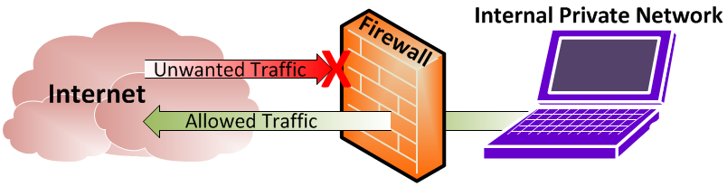(Photo from <https://www.tunnelsup.com/what-is-a-firewall/> )